Software Requirement Specifications
Student Management System



Submitted by
Muhammad Yasir | S23BINFT1M01132

Submitted to
DR. Rizwan Ali Shah

Department of Information Technology
Faculty of Computing
The Islamia University of Bahawalpur

Meeting Details
Sr No | Details | Date | Supervisor Signature
Summary
This document provides the software requirements for a Student Management System. The system is designed to simplify how educational institutions manage student and teacher information in a simple and digital way. It covers the purpose, scope, functional and non-functional requirements, and use cases of the system. The system allows students and teachers to log in to their own accounts and perform tasks related to attendance, grades, and personal information. This document serves as a guide for the development of the system using HTML, CSS, JavaScript, PHP, and MySQL.

Table of Contents
1. Introduction 5
1.1. Purpose 5
1.2. Scope 5
1.3. Product Perspective 5
1.4. User Characteristics 6
1.5. Similar apps and systems/Literature Review 6
1.6. Proposed Technologies 6
2. Requirements 7
2.1. Function Requirements 7
- 2.1.1 User Registration……………….……………………………..….……….…….……7
- 2.1.2 User Login …… ……………………………………………..…………….…..…...7
- 2.1.3 Mark Attendance …………………………………….……..………………….…….7
- 2.1.4 Add Grades……………………………………………………………………..….…7
- 2.1.5 View Student Information………………………………...…………………….…....7
- 2.1.6 Student Dashboard………………………………………………………..……….....7
- 2.1.7 View Grades……..…………………………………………………………………...7
- 2.1.8 View Attendance……………………………………………………………………...7
2.2. Non-Functional Requirements 9
3. Use Cases and Flow of Processes 10
- 3.1. Use Case 1 – User Registration 11
- 3.2. Use Case 2 — User Login…….…………………..……………………...…………...…12
- 3.3. Use Case 3 — Mark Attendance ……………………………………………………….…13
- 3.4. Use Case 4 — Add Grades………………….………………………………………...…..14
- 3.5. Use Case 5 — View Student Information………………………………………..…….….14
- 3.6. Use Case 6 — View Attendance………………………………………………...……..….15
- 3.7. Use Case 7 — View Grades…………………………………………..………………..…15
- 3.8. Use Case 8 — View Dashboard………………………………………………………..…16
4. References 16

Introduction
The Student Management System is a web-based application. It is developed for educational institutions to manage and organize student and teacher records in a digital way. Educational institutes often handle huge student data manually which can lead to errors and loss of information. This system is designed to solve that problem by providing a simple and organized platform where all the important information can be managed in one place. The system covers student registration, teacher login, attendance management, grade management, and a dashboard for quick information access. This project focuses on building a working system that improves how student records are handled in a school or college environment.
  - Purpose
The purpose of this project is to develop a Student Management System which will allow the students and teachers to manage and access the academic information easily. This system will allow instructors to take attendance, input grades and see student information. Students will be able to log in to their accounts to view their attendance, marks and personal details. It has been developed to replace manual record keeping with a faster, more accurate digital system.
  - Scope
This system will include the following features:
User registration, user login for both students and teachers, attendance marking by teachers, grade entry by teachers, student information viewing, and a simple dashboard. The system will be a web application. It will be accessed through a browser. The system will not include any mobile application, SMS notifications, fee management, or library management. Only the features mentioned above will be developed in this project.
  - Product Perspective
This system is a standalone web application. It is not part of any larger existing system. It will be accessed by teachers and students through a web browser using their login credentials. The system will use a MySQL database to store all information and a PHP backend to handle the logic. The front end will be built using HTML, CSS, and JavaScript. It will work as an independent system for managing student and teacher data within an educational institution.
  - User Characteristics
The system will have the following types of users:
- Admin: The admin is responsible for managing the system. Admin can register new users including students and teachers, and oversee all records in the system.
- Teacher: The teacher can log in and mark attendance for students, add grades or marks, and view student information.
- Student: The student can log in and view their own attendance, grades, and personal information through the dashboard.
All users are expected to have basic computer skills and access to a web browser. No advanced technical knowledge is required to use the system.

  - Similar apps and systems/Literature Review
Several student management systems already exist with similar characteristics. Here are some examples:
- OpenSIS is a powerful tool for maintaining student information and grades, its high level of complexity often makes it impractical for small institutions with limited administrative resources.
- Fedena is a school management software with modules such as attendance and grades. However, full access is only available through subscription programs.
- Classter is a cloud-based system for managing student data. It is feature-rich yet overly complex for small-scale application.
The proposed system is simpler, lighter in weight, and specifically built for small to medium-sized educational institutions that require a basic and user-friendly solution without sophisticated features.
  - Proposed Technologies
This system will be developed using the following technologies:
- HTML: The front-end is structured using HTML and styled with CSS to ensure a clean and responsive interface tailored for student and teacher usability
- CSS: For styling and making the interface look clean and simple
- JavaScript: For adding interactivity on the client side
- PHP: For server-side logic and handling requests
- MySQL: For storing and managing all data including student, teacher, attendance, and grade records

2. Requirements
This system will allow admins to register new students and teachers. Once registered, each user will have their own login account. Teachers will be able to log in and mark attendance for students, add grades or marks. Teachers can view the information of students. Students will be able to log in and check their own attendance records, grades, and personal information. The system will also include a dashboard that shows important information. The main goal of the system is to make the management of student records easier and more organized compared to manual processes.

2.1. Functional Requirements

2.1.1. User Registration
- Name: FR001
- Purpose: User registration allows the admin to add new students and teachers into the system so they can log in and use the system.
- User(s): Admin
- Input:
1. Full Name: The full name of the student or teacher
2. Email: A valid email address that will be used for login
3. Password: Must be at least 8 characters long and include at least one number
4. Role: Either Student or Teacher
5. Phone Number: A working phone number (11 digits)
6. Address: Current address of the user
- Output: A new user account is created in the system and the user can now log in

2.1.2. User Login
- Name: FR002
- Purpose: Login allows registered students and teachers to access their accounts and use the features available to them.
- User(s): Admin, Teacher, Student
- Input:
  - Email: Registered email address
  - Password: Password set during registration
• Output: User is logged in and redirected to their respective dashboard
2.1.3. Mark Attendance
- Name: FR003
- Purpose: This feature allows teachers to mark attendance for students on a daily basis.
- User(s): Teacher
- Input:
- Student List: System displays list of students
- Attendance Status: Present or Absent for each student
- Date: Automatically recorded by the system
• Output: Attendance is saved in the database and can be viewed later

2.1.4. Add Grades
- Name: FR004
- Purpose: Teachers can add or update marks and grades for students for each subject.
- User(s): Teacher

- Input:
- Student Name: The student whose grade is being added
- Subject: The subject for which the grade is being entered
- Marks: Numerical marks obtained by the student
• Output: Grades are saved and visible to the student in their account

2.1.5. View Student Information
- Name: FR005
- Purpose: Teachers can view the personal and academic information of any student in the system.
- User(s): Teacher
- Input:
  - Student Name or ID: Used to search for a specific student
• Output: Student profile including personal details, attendance, and grades is displayed

2.1.6. Student Dashboard
- Name: FR006
- Purpose: Students can view their own information including attendance, grades, and personal details in one place.
- User(s): Student
- Input: Login Credentials: Student must be logged in
• Output: Dashboard showing student's attendance summary, recent grades, and personal information

2.1.7. View Grades
- Name: FR007
- Purpose: Students can view their own grades and marks for each subject in the system.
- User(s): Student
- Input: Login Credentials: Student must be logged in
- Output: List of grades displayed for each subject

2.1.8. View Attendance
- Name: FR008
- Purpose: Students can view their own attendance record in the system.
- User(s): Student
- Input: Login Credentials: Student must be logged in
- Output: Attendance record displayed showing present and absent dates

2.2. Non-Functional Requirements
- Usability: The system should have a simple and clean interface that is easy to use for both teachers and students without any technical training.
- Performance: The system should load pages quickly and respond to user actions without significant delays even when multiple users are using it at the same time.
- Security: User passwords should be stored securely. Each user should only be able to access the data that belongs to their role.
- Reliability: The system should work correctly and consistently without errors during normal use.
- Maintainability: The code should be written in a clean and organized way so that future changes or updates can be made easily.
- Compatibility: The system should work on all major web browsers such as Chrome, Firefox, and Edge.

3. Use Cases and Flow of Processes
Use cases describe how different users interact with the system to complete specific tasks. The system has five actors: Admin, Teacher, Student, and two supporting actors for external interaction. The diagram below shows the system level use case diagram for the Student Management System.

Figure 1: System Level Use Case Diagram
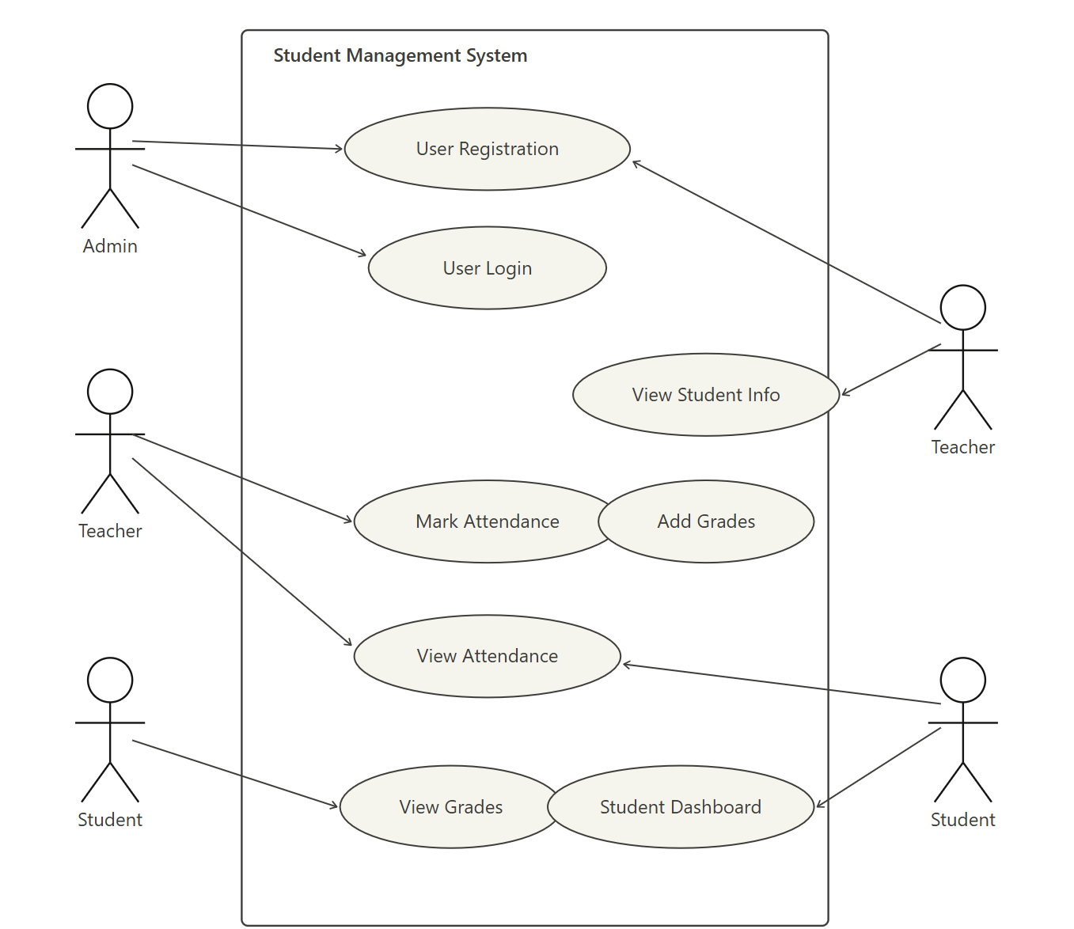

3.1 Use Case 1 User Registration
ID | UC001
Name | Sign Up
Description | This use case describes the process of registering a new student or teacher into the system
Requirement(s) | FR001
Actor(s) | Admin
Precondition | Admin must be logged in to the system
Postcondition | A new user account is created and the user can log in
Basic Flow | - Basic Flow Admin clicks on Register New User. Admin enters the required details: Full Name, Email, Password, Role, Phone, and Address. System validates the inputs. Email must be in valid format. Password must be 8 characters including a number. Phone must be 11 digits. On successful validation the system creates the account.  - Alternative Flow Admin corrects any invalid field and resubmits.  - Exceptions Invalid inputs — system shows an error message.

3.2. Use Case 2 — User Login

ID | UC002
Name | User Login
Description | This use case describes the login process for Admin, Teacher, and Student
Requirement(s) | FR002
Actor(s) | Admin, Teacher, Student
Precondition | User must already be registered in the system
Postcondition | User is logged in and directed to their dashboard
Basic Flow | 1- Basic Flow User opens the login page. User enters Email and Password. System checks the credentials in the database. On success, user is redirected to their role-based dashboard.  2- Alternative Flow User resets password if forgotten.  3- Exceptions Wrong email or password — system shows an error message.

3.3. Use Case 3 — Mark Attendance

ID | UC003
Name | Mark Attendance
Description | This use case describes how a teacher marks attendance for students
Requirement(s) | FR003
Actor(s) | Teacher
Precondition | Teacher must be logged in
Postcondition | Attendance is saved in the system for the selected date
Basic Flow | 1- Basic Flow Teacher opens the Attendance section. System shows the list of students. Teacher marks each student as Present or Absent. Teacher submits the attendance. System saves the record with the current date.  2- Alternative Flow Teacher updates previously entered attendance.  3- Exceptions System fails to save — teacher is shown an error message.

3.4. Use Case 4 — Add Grades
ID | UC004
Name | Add Grades
Description | This use case describes how a teacher adds or updates grades for students
Requirement(s) | FR004
Actor(s) | Teacher
Precondition | Teacher must be logged in
Postcondition | Grades are saved and visible to the student
Basic Flow | 1- Basic Flow Teacher opens the Grades section. Teacher selects a student and subject. Teacher enters the marks. System saves the grade.  2- Alternative Flow Teacher updates existing grade for a student.  3- Exceptions Invalid marks entry — system shows a validation error.

3.5. Use Case 5 — View Student Information
ID | UC005
Name | View Student Information
Description | This use case describes how a teacher views the information of a student
Requirement(s) | FR005
Actor(s) | Teacher
Precondition | Teacher must be logged in
Postcondition | Student profile is displayed on the screen
Basic Flow | 1- Basic Flow Teacher opens the Student List. Teacher searches for a student by name or ID. System retrieves and displays student information.  2- Alternative Flow Teacher browses through the full student list.  3- Exceptions Student not found — system shows a not found message.

3.6. Use Case 6 — View Attendance
ID | UC006
Name | View Attendance
Description | This use case describes how a student views their own attendance record
Requirement(s) | FR008
Actor(s) | Student
Precondition | Student must be logged in
Postcondition | Attendance record is displayed to the student
Basic Flow | 1- Basic Flow Student logs in and opens the Attendance section. System retrieves and displays the attendance records.  2- Exceptions No records found — system shows an empty state message.

3.7. Use Case 7 — View Grades
ID | UC007
Name | View Grades
Description | This use case describes how a student views their own grades
Requirement(s) | FR007
Actor(s) | Student
Precondition | Student must be logged in
Postcondition | Grades are displayed to the student
Basic Flow | 1- Basic Flow Student logs in and opens the Grades section. System retrieves and displays the grades for each subject.  2- Exceptions No grades added yet — system shows an empty state message.

3.8. Use Case 8 — Student Dashboard
ID | UC008
Name | Student Dashboard
Description | This use case describes the dashboard that shows a summary of student information in one place
Requirement(s) | FR006
Actor(s) | Student
Precondition | Student must be logged in
Postcondition | Dashboard is displayed with attendance summary, recent grades, and personal info
Basic Flow | 1- Basic Flow: Student logs in. The system automatically loads the dashboard. The dashboard shows an attendance summary, recent grades, and personal details.  2- Exceptions: Data not available — system shows default empty values.

4. References
[1] I. Sommerville, Software Engineering, 10th ed. Pearson, 2016.
[2] R. S. Pressman, Software Engineering: A Practitioner's Approach, 8th ed. McGraw-Hill, 2014.
[3] OpenSIS Student Information System. [Online]. Available: https://www.opensis.com
[4] Fedena School Management Software. [Online]. Available: https://www.fedena.com
[5] Classter Student Information System. [Online]. Available: https://www.classter.com

